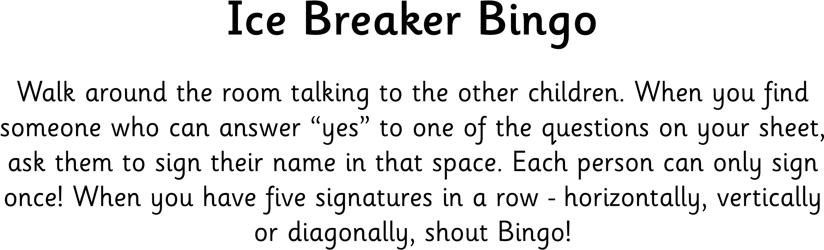

|  |  |  |  |  |
| --- | --- | --- | --- | --- |
| B | I | N | G | O |
| HAS NEVER BROKEN A BONE | HAD BRACES | DOES NOT HAVE ANY PETS | WAS BORN IN DECEMBER | LEFT HANDED |
| ONLY CHILD | HAS BEEN TO EUROPE | ALLERGIC TO PEANUTS | HAS BEEN SKIING | CAN SPEAK ANOTHER LANGUAGE |
| WAS NOT BORN IN THE UNITED STATES | HAS A TWIN | **FREE** | PLAYS BASKETBALL | IS AFRAID OF HEIGHTS |
| PLAYS A MUSICAL INSTRUMENT | HAS GREEN EYES | HAS A PET CAT | HAS A SISTER | PLAYS GOLF |
| HAS GLASSES | DOES NOT LIKE CHOCOLATE | HAS FLOWN IN A HELICOPTER | KNOWS HOW TO SURF | LIKES SPICY FOOD |